Department of BSBE
Indian Institute of Technology Kanpur
Kanpur (UP) 208016 India

Enquiry date: August 25,2021 Enquiry No: IITK/BSBE/AR/2021/01
Last Date of submission: September 10, 2021, 1700 hrs.

Sealed quotations are invited for described below.

Human electroencephalography and psychophysics laboratory

Objective:

- Reduce extraneous auditory sounds.
- Reduce electrical interference.
- Improve thermal insulation.
- Maintain good ventilation, comfortable temperature settings etc.
- Maintain outer facade.

Gold standard is a soundproof room. But that is expensive. Following approach is cheap but effective – “low-tech” solution.

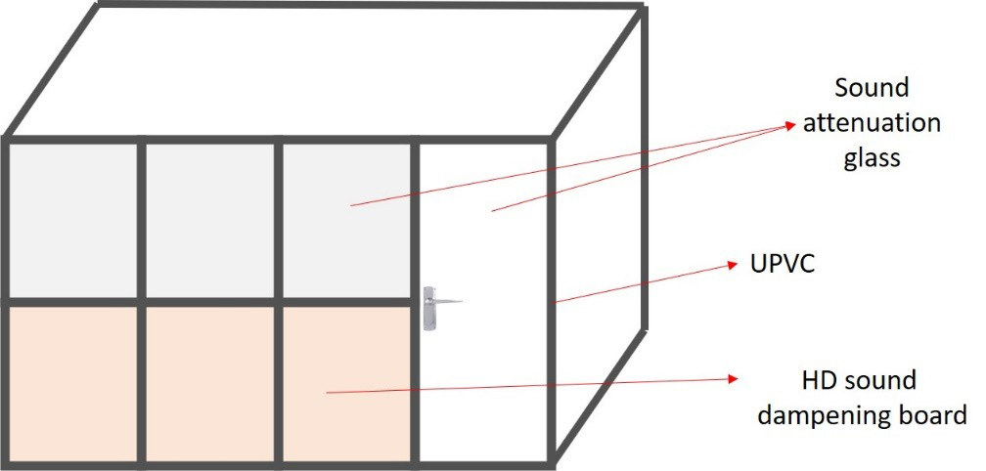

Experiment room (2x)

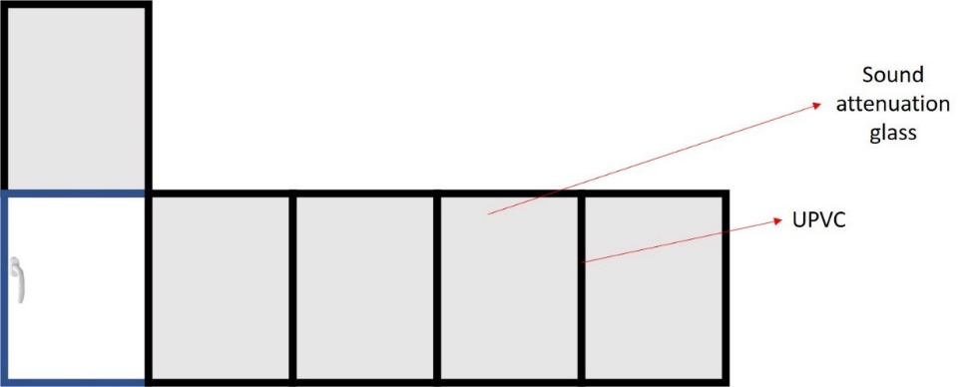

Windows (2x)

Approach:

- Replace single panel glass windows with double panel glass windows.
- Attenuate noise from the Gate 3 roadside, reduce heat while maintaining façade.
- Design two experimental lab spaces – for EEG, pupillometry and sleep cognition studies.
- Use superior technology, ensure elegance, retain flexibility to make changes, but keep costs low.
- Meet scientific requirements (sound below 35 dB, other specifications attached)
- Branded companies and certified, authorized representatives (attached)

Solution:

Windows:

- Glass: Saint Gobain (Specs: attached, Brochure: attached)
Cost per Sq ft – Rs. 966. Total Sq. ft – 127

- Unplasticized polyvinyl chloride frame: Encraft (Specs: attached, Brochure: attached)

Cost per Sq ft – Rs. 922 Total Sq. ft – 127

Experiment rooms:

- Glass: Saint Gobain (Specs: attached, Brochure: attached)
Cost per Sq ft – Rs. 912 Total Sq. ft – 121

- Unplasticized polyvinyl chloride frame: Encraft (Specs: attached, Brochure: attached)

Cost per Sq ft – Rs. 726 Total Sq. ft – 428

- Mass loaded vinyl: Tranquil (Specs: attached, Brochure: attached): Cost per Sq ft – Rs. 139
Total Sq. ft – 308

  - Glass: Saint Gobain toughened glass (Specs: attached, Brochure: attached)
Cost per Sq ft – Rs. 215
Total Sq. ft – 308
References:
- Luck SJ. Introduction to the event-related potential technique. Cambridge, MA: MIT Press; 2014
- Ledwidge P., Foust J., Ramsey A. Recommendations for Developing an EEG Laboratory at a Primarily Undergraduate Institution. J. Undergrad. Neurosci. Educ. 2018;17: A10–A19

Address:
Dr. Arjun Ramakrishnan
Department of Bio Engineering and Bio Sciences,
Indian Institute of Technology Kanpur,
GT Road, Kalyanpur, Kanpur. UP-208016
Email: arjunr@iitk.ac.in / Phone – 0512-259-4104

Terms and Conditions:
- The Institute reserves the right of accepting or rejecting any/all quotations without assigning any reason thereof.
- Payment terms will be 50% on supply of material and 50% after successful completion of work.
- The Validity of quotes should be 90 days.
- The work should be completed within 75 days of receipt of purchase order.
- All interested eligible bidders are requested to submit their bids in hard copy to the undersigned within 10 days of floating this tender online on IITK website.
- Bids should be submitted in two separate covers, sealed separately, and put in one outer cover. The covers should be clearly marked for its contents.
a. Technical Bid
b. Financial Bid
- TECHNICAL BID:
a. List of Documents to be enclosed-
i. Scanned copy of Bank details.
ii. Scanned copy of work experience.
iii. Scanned copy of certificate of GST.
iv. Scanned copy of specifications/brochures & tender acceptance letter on Appendix
v. Scanned copy of another document mentioned in tender document (if any)
8. FINANCIAL BID
a. The currency of all quoted rates shall be Indian Rupees. All payment shall be made in Indian Rupees.
b. In preparing the financial bids, bidders are expected to consider the requirements and conditions laid down in this Tender document.
c. GST and other taxes if any should be shown separately and clearly on the bid.

Appendix -1

TENDER ACCEPTANCE LETTER
(To be given on Company Letter Head)

Date: _____________
To,
______________________
______________________
______________________

Sub: Acceptance of Terms & Conditions of Tender.

Tender Reference No: ________________________

Name of Tender / Work: - _______________________________________________________________

Dear Sir,
1. I/ We have downloaded / obtained the tender document(s) for the above mentioned ‘Tender/Work’ from the web site(s) namely: _______________________________________________________________________as per your advertisement, given in the above mentioned website(s).
2. I / We hereby certify that I / we have read the entire terms and conditions of the tender documents from Page No. _______ to ______ (including all documents like annexure(s), schedule(s), etc.,), which form part of the contract agreement and I / we shall abide hereby by the terms / conditions / clauses contained therein.
3. The corrigendum(s) issued from time to time by your department/ organisation too have also been taken into consideration, while submitting this acceptance letter.
4. I / We hereby unconditionally accept the tender conditions of above-mentioned tender document(s) / corrigendum(s) in its totality / entirety.
5. I / We do hereby declare that our Firm has not been blacklisted/ debarred/ terminated/ banned by any Govt. Department/Public sector undertaking.
6. I / We certify that all information furnished by our Firm is true & correct and in the event that the information is found to be incorrect/untrue or found violated, then your department/ organisation shall without giving any notice or reason therefore or summarily reject the bid or terminate the contract, without prejudice to any other rights or remedy including the forfeiture of the full said earnest money deposit absolutely.

Yours Faithfully,
(Signature of the Bidder, with Official Seal)

