Molecular Simulation of Complex Fluids and Interfaces Abstract (14 point)

First Author¹⁾, Second Author²⁾, Third Author^{3)*} (12 point, presenter underlined)
¹⁾ Affiliation of the first author, including Department, Institution and City. (11 point)
²⁾ Affiliation of the second author, including Department, Institution and City. (11 point)
³⁾ Affiliation of the third author, including Department, Institution and City. (11 point)

* Corresponding Author: email@iitk.ac.in

(12point) The abstract for the Symposium on Molecular Simulation of Complex Fluids and Interfaces should be written in English. The maximum length of the abstract is 1 page. The abstracts accepted for presentation will be published as a soft copy and distributed to participants of the conference.
The abstract must be prepared using this template. Authors should be listed consecutively by their full names. Indicate the presenting author by underlining the name. The content should be in 12 point, single space, and single column. Type the text only within the text area. Everything on the page must fit within the text area. Kindly avoid fancy Font Styles; use standard fonts like Times New Roman, Arial, Calibri, Cambria etc. Please do not alter the margins, text sizes, or other formatting used in this template. You may include table and/or figures in the abstract (optional). Place the table caption over the table. Use Roman numerals (Table I, Table II, etc.) for the table number. All figures must be reduced to the appropriate size and positioned in place. Place the figure above the caption and number all figures with Arabic numerals (Fig. 1, Fig. 2, etc.). Figure may be submitted in color or grayscale.
Please submit your abstract in Microsoft Word .doc/.docx or PDF format via the Symposium website http://iitk.ac.in/molsim/. Fill up the Google Form and upload a scanned copy of your ID proof and the Abstract in the respective sections. The abstract submission deadline is December 31, 2019. You will be notified about the status of your abstract submission within 3 weeks of submission or by January 5, 2020, whichever is earlier.

References (10 point)
[1] F. Author, et al., Journal, volume (year), 1-10.
[2] F. Author, et al., Book Title, fourth ed., Publisher, Place of Publication, year.
[3] F. Author, et al., Chapter title in: F. Editor, et al., Book Title, Publisher, Location, year, pp. 1-10.

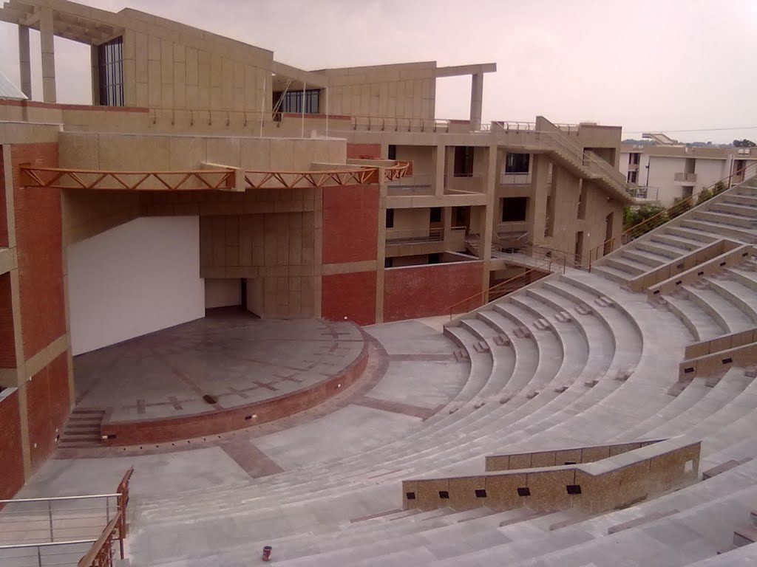 | 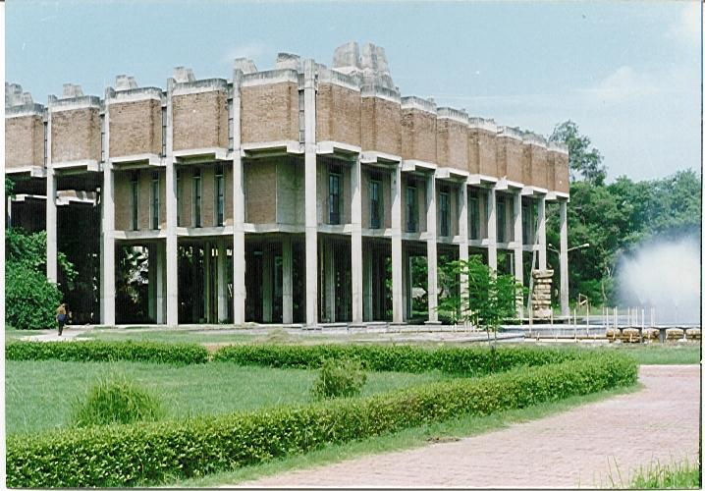
Fig.1 (8point) Figure description. | Fig.2 (8point) Figure description.

