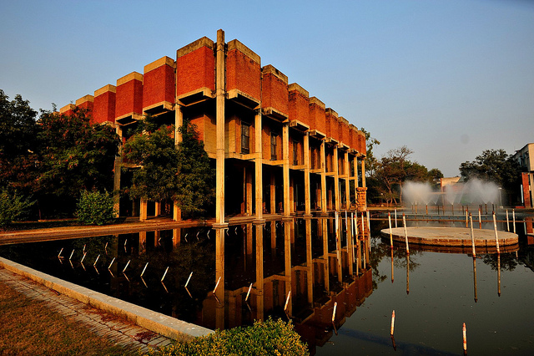

ISHTIHAR

Team OPTiMa
By

What?
Ishtihar- the online Poster Making competition brought to you by OPtiMa – The operations and Marketing club, MBA IIT Kanpur.

Where
Online event. Please check our FB page for Questions, Results and all relevant details https://www.facebook.com/Prabandhan.MBA.IITK?ref=bookmarks.
We shall post the same in our Twitter account also: https://twitter.com/prabandhan2015

When?

REGISTRATION STARTS: 22nd August

REGISTRATION ENDS: 1st September

SUBMISSION OF VIDEOS: 23:59:59, 12th September

ONLINE PROMOTION BEGINS: 13th September

ONLINE PROMOTION ENDS: 23rd September

DECLARATION OF RESULTS: 26th September

Who?
This is open to all MBA students across the country.

How?
• The competition is completely online-based
• Participants must register individually. They need to prepare a poster based on the theme given above
• The poster should be depicting the idea as aesthetically and effectively as possible
• The poster needs to be uploaded on the Facebook page of the Event. The participants must promote their entry through Facebook.
POINTS BREAKDOWN:
• 60% for the content.
• 40% for likes and shares.
Rules and Format:
- This is an individual event.
- The poster should be submitted before the given deadline at prabandhan.mbaiitk@gmail.com
- The subject of the mail and file should be named as MemberName_Campus.
- A short description should be attached when you send the poster to the organizers.
- THE FOLLOWING WILL LEAD TO DISQUALIFICATION, IF THE POSTER:
  - Has plagiarized content.
  - Has controversial, vulgar or offensive content.
  - Does not adhere to the deadlines for registration and submission.
- PRIZES:
• Winner – 2000 (1.5K+.5K)
• 1st Runner up – 1500 (1K+0.5K)
• 2nd Runner up – 1000 (0.5K+0.5K)

- FOR ANY QUERIES, CONTACT:
  - Ganesh Shaji (Mob. - 9447865589)
  - Nikhil P K (Mob. – 7275527697)

