Tag Wars’15

Team Cognition
By

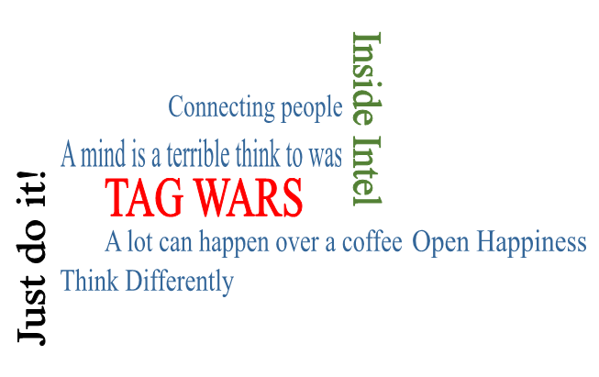
Tired of old boring tag lines. Here is a chance to create your own and win exciting prizes.

What?
TagWars is an online event to find the most Creative, Catchy and Convincing Tag Line.
Few images will be floated every week and participants have to link those images and come up with unique tag lines.

Where?
Online event. Please check our FB page for Questions, Results and all relevant detailshttps://www.facebook.com/Prabandhan.MBA.IITK?ref=bookmarks.
We shall post the same in our Twitter account also :https://twitter.com/prabandhan2015

When?
Each Saturday @ 09:00 P.M.

Who?
Open for all B School Grads.

How?
Creativity + Logical Connect + Memorable = Perfect Tag Line

Rules and Format:
- Key Points:
- Students have to register individually.
- The event will start from 29th Aug 2015 and it will continue till 26th Sep 2015
- 1 Question every Saturday @09:00 pm (3 hour window to submit the solution through Google form)
- Question and submission of Google form link will be posted on Prabandhan 2015 page @ 09 pm during event dates, so like our FACEBOOK page and stay tuned.
- All the Tag Lines will be judged by Industry experts and Faculty.

- Awards
Participate and win prizes worth Rs. 1500!!!
- Announcement of Results
Every Sunday of the next week.
- For any queries, Contact:
Bala Yesu Achyuta: +919453835503
Navneet Malviya: +919198261960

